Name: _____________________________________

Score: _________/25

Reaction Time Assessment

1. What was your hypothesis?

(1 mark)

2. Identify the independent and dependant variables in this investigation

(2 marks)

3. Identify THREE extraneous (uncontrolled) variables, or any other sources of error in this experiment. Describe how you could control each variable.

(3 marks)

4. Do you think your hypothesis was supported with the data collected? Why/Why not?

(1mark)

5. Scientists need to be mindful of the practise effect in experiments such as this one.
What do you think the practise effect is?

(1 mark)

6. To find out if your experiment was affected by the practise effect, plot your data for three members of your group for their 5 trials for the “Before” or “Normal” situation on the grid below (Hint. Trial number is on the horizontal axis).
(3 marks)
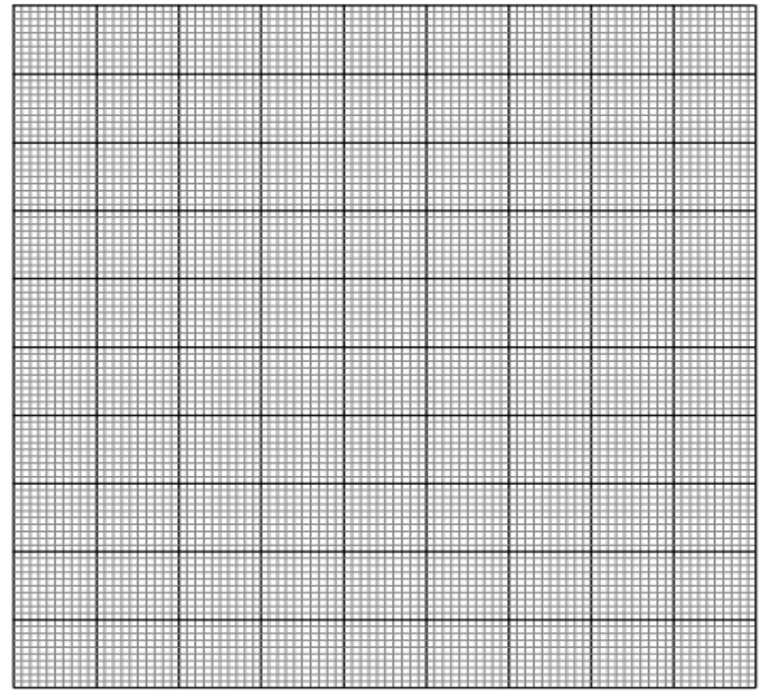

7. Using evidence from your graph to decide if you data have been affected by the practise effect.

(2 marks)
8. What are the overall median and the range of the data from all participants displayed on the graph above? Explain how you calculated each one.

(2 marks)

9. a) Define validity and comment on the validity of your experiment.

(2 marks)

b) How could you change your method to increase the validity of your experiment. (there is always room for improvement)

(1 mark)

10. a) Define reliability and comment on the reliability of your experiment.

(2 marks)

b) How could you change your method to increase the reliability of your experiment. (there is always room for improvement)

(1 mark)

11. Safety of the participants in an investigation should be considered before the trials begin by conduction of a risk assessment.
Were there any risks involved in your investigation? Explain.
If not, describe a version of this experiment would have involved risks to the participants.

(1mark)

12. There are 3 types of neuron. Describe the role of each type in the reaction being tested in your investigation.

(3 marks)

